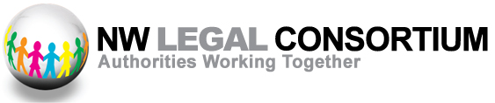
North West Legal Consortium AGM
To be held on Tuesday 3rd October 2023
At Aintree Racecourse
commencing at 4.30pm
All legal staff in member organisations are welcome to attend

- Introductions/Welcome

- Looking back and Looking Forward

What did the Consortium do in 2022/23?
What lies ahead for 2023/24

- Consortium Budget position

Budget position at end 2022/23
To consider a proposal to increase the level of Membership Subscriptions for 2024/25

- Governance

To agree appointments to Consortium Management Board for period to Consortium Annual Training Event, Autumn 2024

- Any other Business

